**CRAFT CMS**

Install CraftCMS  
 composer create-project "craftcms/craft:^4"

Run this command in the Craft folder to download Craft CMS.  
After this, create a virtual host pointing to the web folder.  
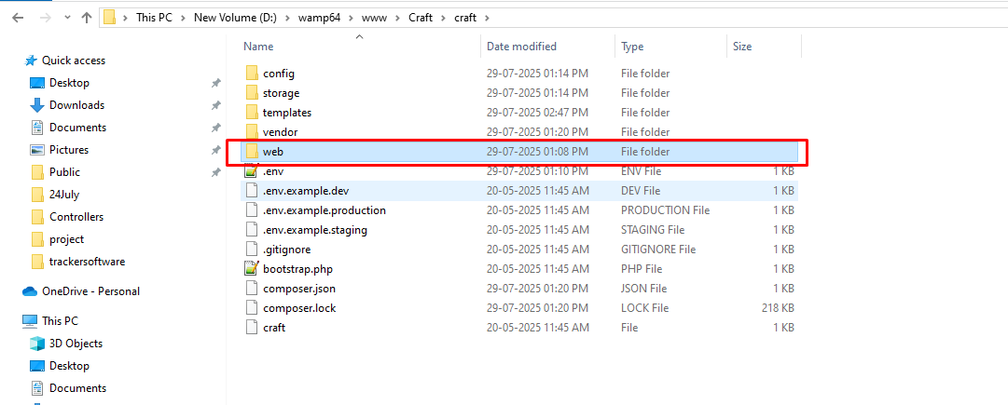

Then, open the URL http://yourvirtualhost/admin/install in your browser.

Then, follow the installation steps, such as entering admin and database details.

After successful installation, access the admin panel by visiting http://yourvirtualhost/admin.

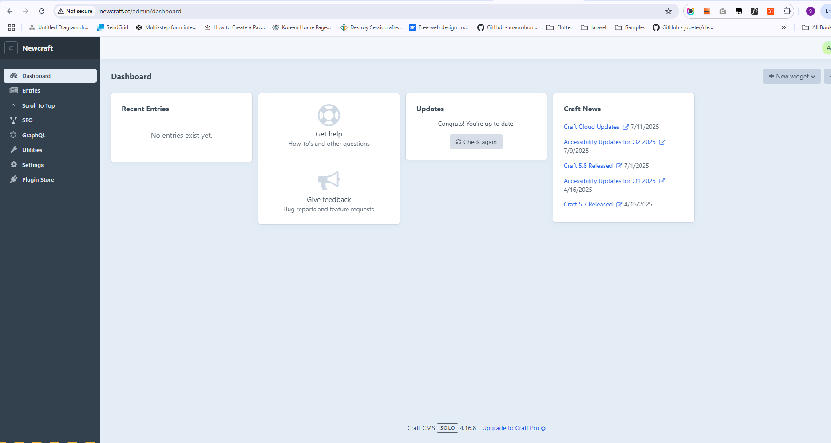

**For Creating Page:**

#### **Create a New Section**

* Go to: **Control Panel → Settings → Sections**
* Click **“New Section”**
* Fill in the following:  
  + **Name**: About
  + **Handle**: about
  + **Type**: Choose Single

Save the section.

#### 

#### **2. Create a Field Group and Fields (if not already)**

* Go to: **Settings → Fields**
* Create a **Field Group** (e.g., “Pages”)
* Add fields such as:
  + Rich Text

Save

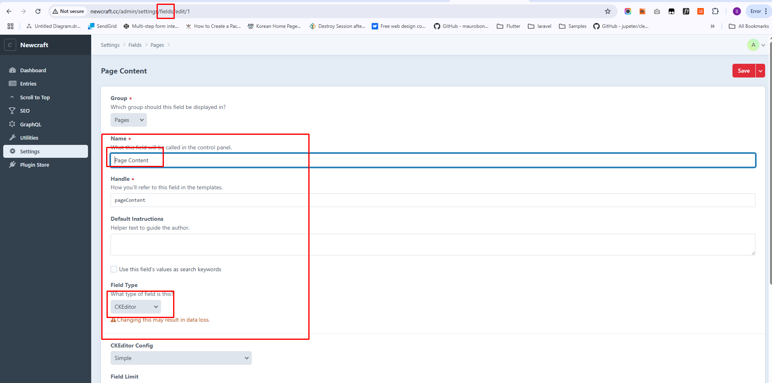

#### **3. Assign Fields to a Field Layout**

* Go back to **Settings → Sections → About**
* Click **Edit Entry Type**
* **Add your custom fields to the layout**
* **Save.**

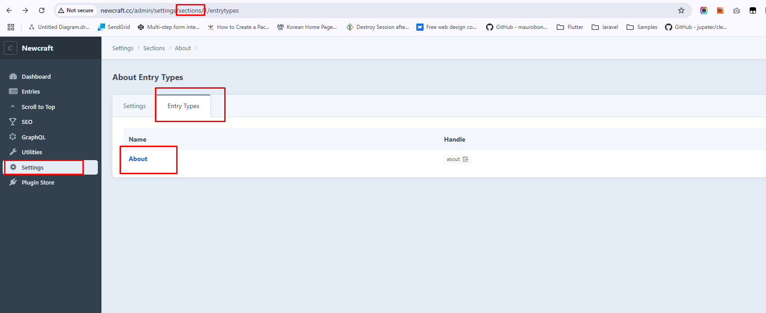

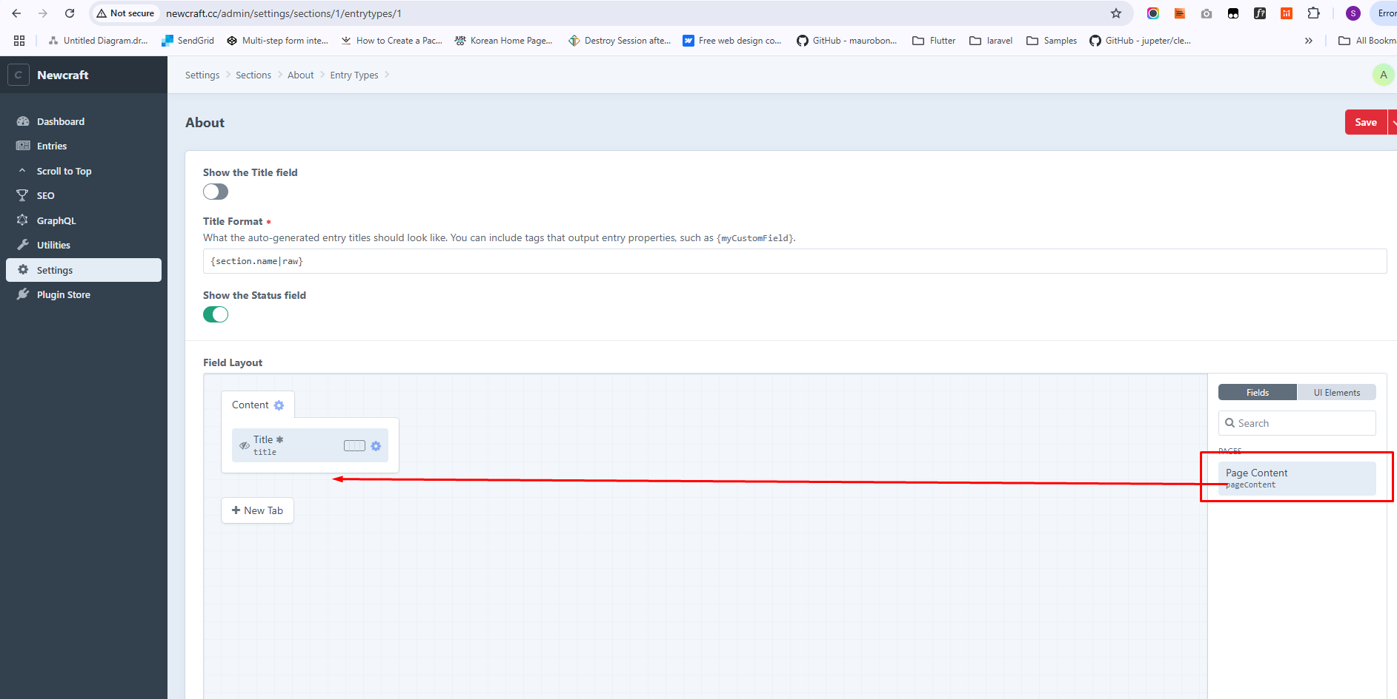

#### **4. Add Page Content**

* **Go to: Entries → About**
* **You’ll now see the “About” page editor**
* **Add your content (text, images, etc.)**
* **Save.**

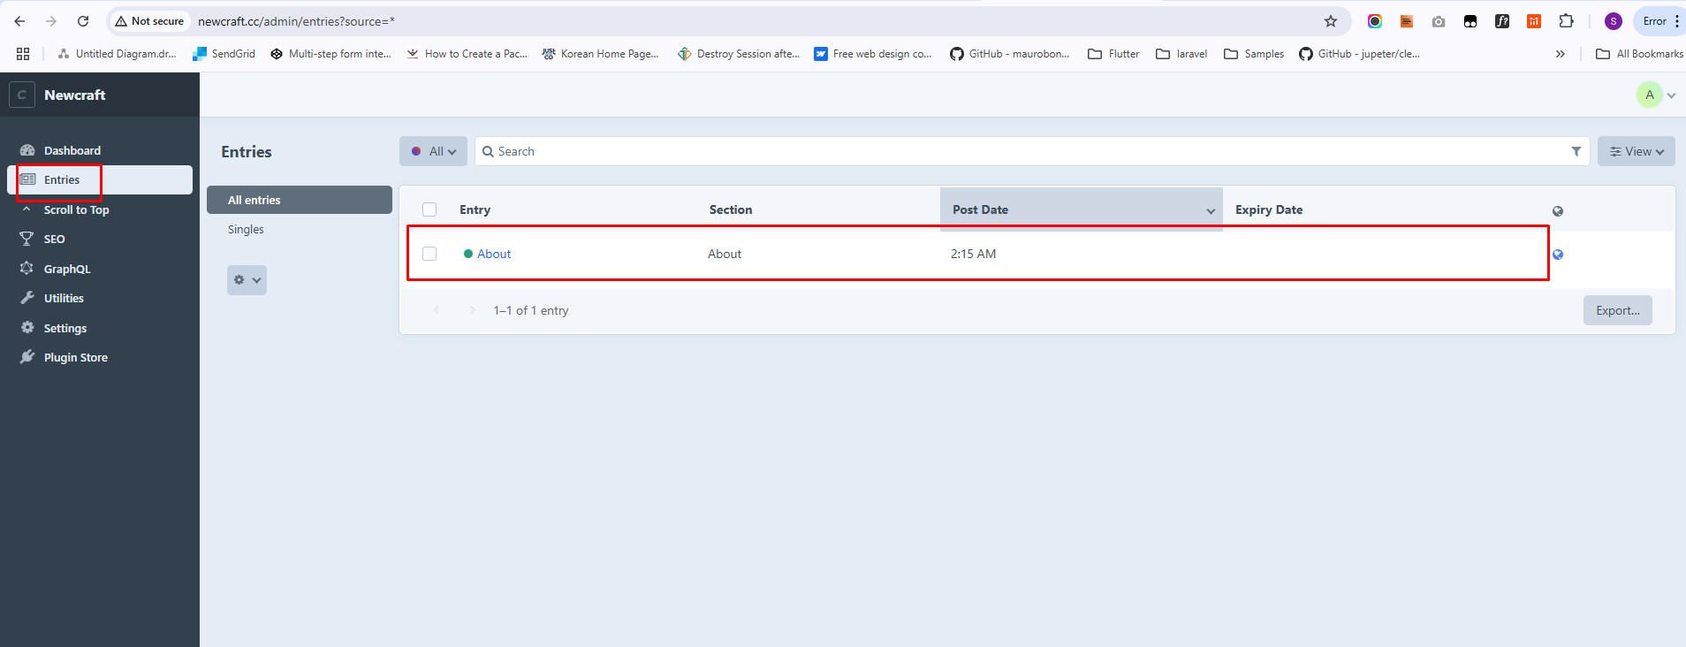

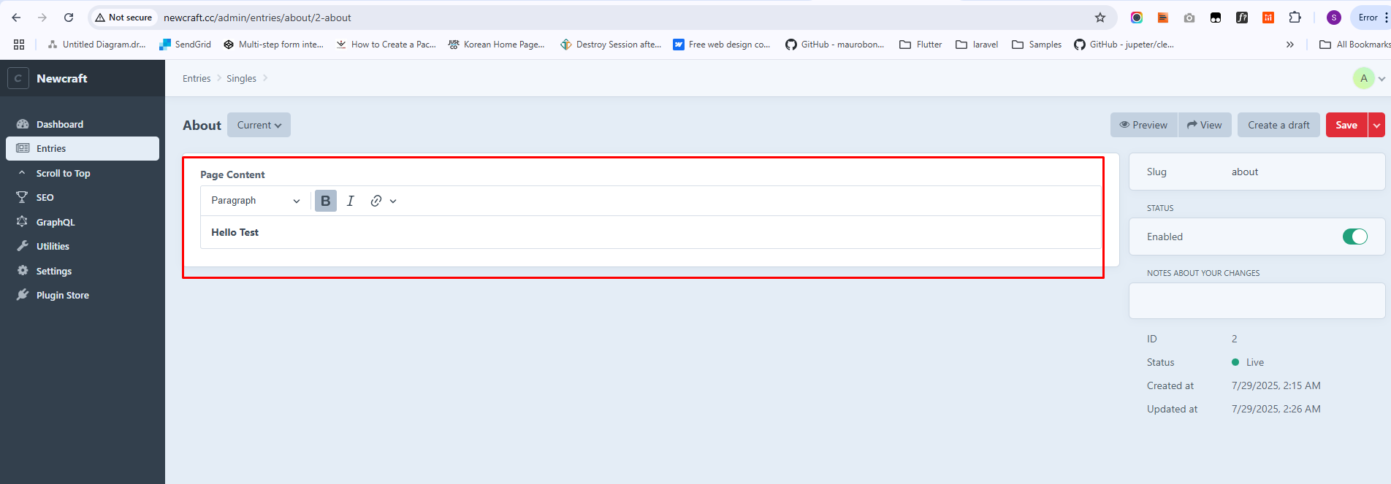

**5. Create the Template File**

**About.twig**

**{% block content %}**

**<h1>{{ entry.title }}</h1>**

**<div>{{ entry.pageContent | raw }}</div>**

**{% endblock %}**

